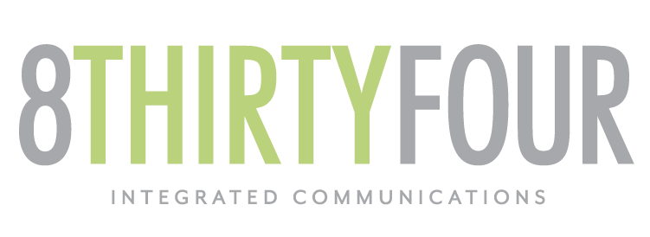

2019 Trends in Finishes
For Client Review
November 13, 2018

When it comes to your home or business, the selected finishes for decks, gates, fences, and more, are all key decisions. But, just as important, is picking out the perfect hardware in just the right finish.

The type of finishes used in a space don’t have to match, but they should complement each other.

Here are the most popular finishes we are going to see in 2019:

Brass
The most popular brass finish is bright brass, a total classic. Bright brass finishes are highly reflective and can have a coat of warm, golden sheen which give it a vintage look. Bright brass is a readily available finish, is inexpensive, and matches most woods.

Nickel
Our favorite nickel finish is distressed nickel. The distressed nickel finish is textured and filled with character. The rustic look of this finish is a guaranteed conversation starter in whatever room it is placed.

You have most likely seen this finish in urban buildings and apartments, and if you haven’t seen it yet, be on the lookout! Distressed nickel is quickly growing in popularity.

Bronze to Black
Matte black finishes offer traditional looks that blend well with modern styles. A matte black finish will add subtle luxury to any room or space.

We particularly love selecting matte black finishes for our fencing hardware because it often blends well with a variety of fence types and materials.

With so many options, it can be overwhelming to decide what products to carry or select. Give us a call so we can help!

